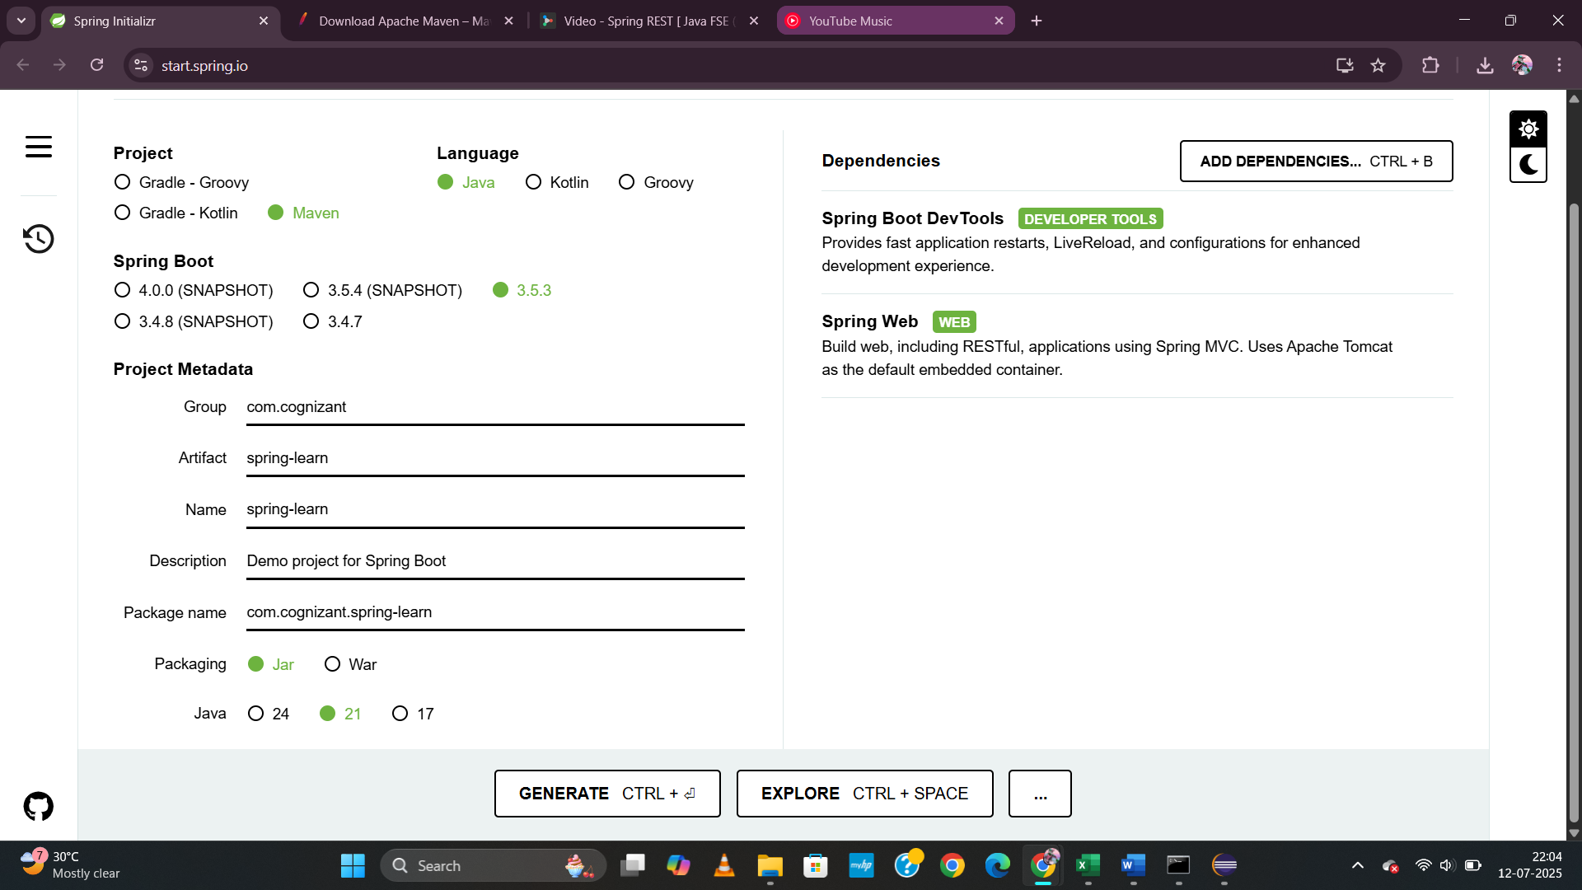

Build the project using ‘mvn clean package -Dhttp.proxyHost=proxy.cognizant.com -Dhttp.proxyPort=6050 -Dhttps.proxyHost=proxy.cognizant.com -Dhttps.proxyPort=6050 -Dhttp.proxyUser=123456’ command in command line

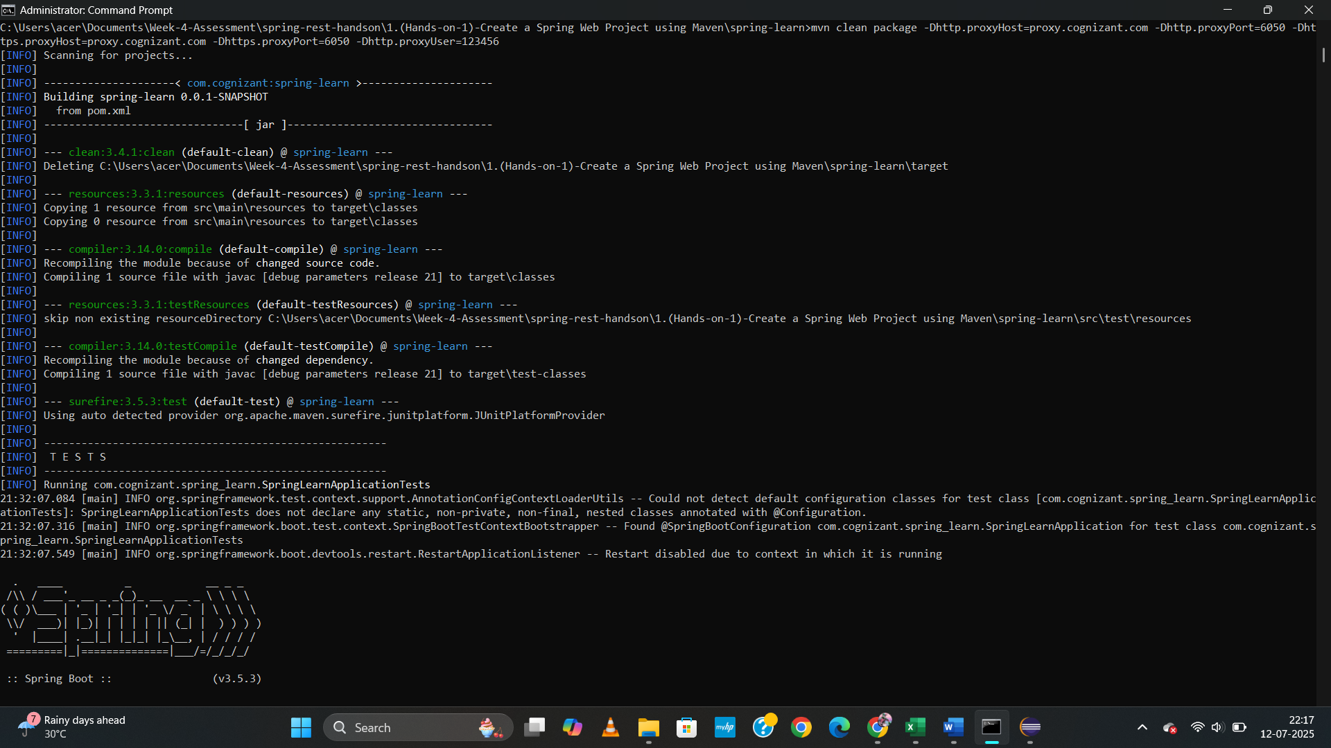

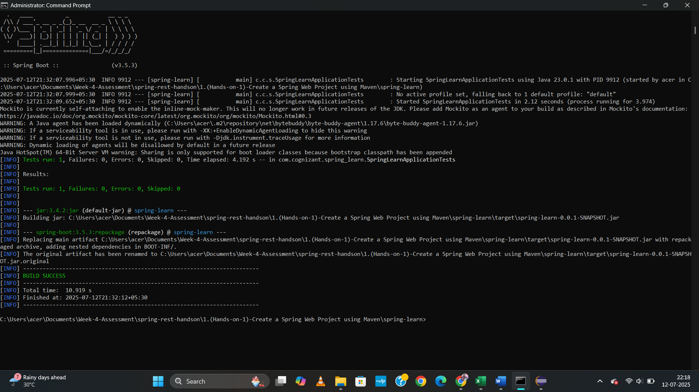

OPENING DEPENDENCY 'Hierarchy' and the dependency tree HAIRARCHY

SpringLearnApplication.java

package com.cognizant.spring_learn;

import org.springframework.boot.SpringApplication;

import org.springframework.boot.autoconfigure.SpringBootApplication;

@SpringBootApplication

public class SpringLearnApplication {

public static void main(String[] args) {

SpringApplication.run(SpringLearnApplication.class, args);

}

}

**Pom.xml**

<project xmlns="http://maven.apache.org/POM/4.0.0"

xmlns:xsi="http://www.w3.org/2001/XMLSchema-instance"

xsi:schemaLocation="http://maven.apache.org/POM/4.0.0

http://maven.apache.org/xsd/maven-4.0.0.xsd">

<modelVersion>4.0.0</modelVersion>

<groupId>com.cognizant</groupId>

<artifactId>spring-learn</artifactId>

<version>0.0.1-SNAPSHOT</version>

<name>spring-learn</name>

<description>Spring Boot Web Application</description>

<parent>

<groupId>org.springframework.boot</groupId>

<artifactId>spring-boot-starter-parent</artifactId>

<version>3.5.3</version>

<relativePath/> <!-- lookup parent from repository -->

</parent>

<properties>

<java.version>21</java.version>

</properties>

<dependencies>

<!-- Spring Boot Starter for building web applications -->

<dependency>

<groupId>org.springframework.boot</groupId>

<artifactId>spring-boot-starter-web</artifactId>

</dependency>

<!-- Spring Boot DevTools for live reload -->

<dependency>

<groupId>org.springframework.boot</groupId>

<artifactId>spring-boot-devtools</artifactId>

<scope>runtime</scope>

<optional>true</optional>

</dependency>

<!-- For Testing -->

<dependency>

<groupId>org.springframework.boot</groupId>

<artifactId>spring-boot-starter-test</artifactId>

<scope>test</scope>

</dependency>

</dependencies>

<build>

<plugins>

<!-- Maven plugin to package the Spring Boot application -->

<plugin>

<groupId>org.springframework.boot</groupId>

<artifactId>spring-boot-maven-plugin</artifactId>

</plugin>

</plugins>

</build>

</project>